Annual Report 2016

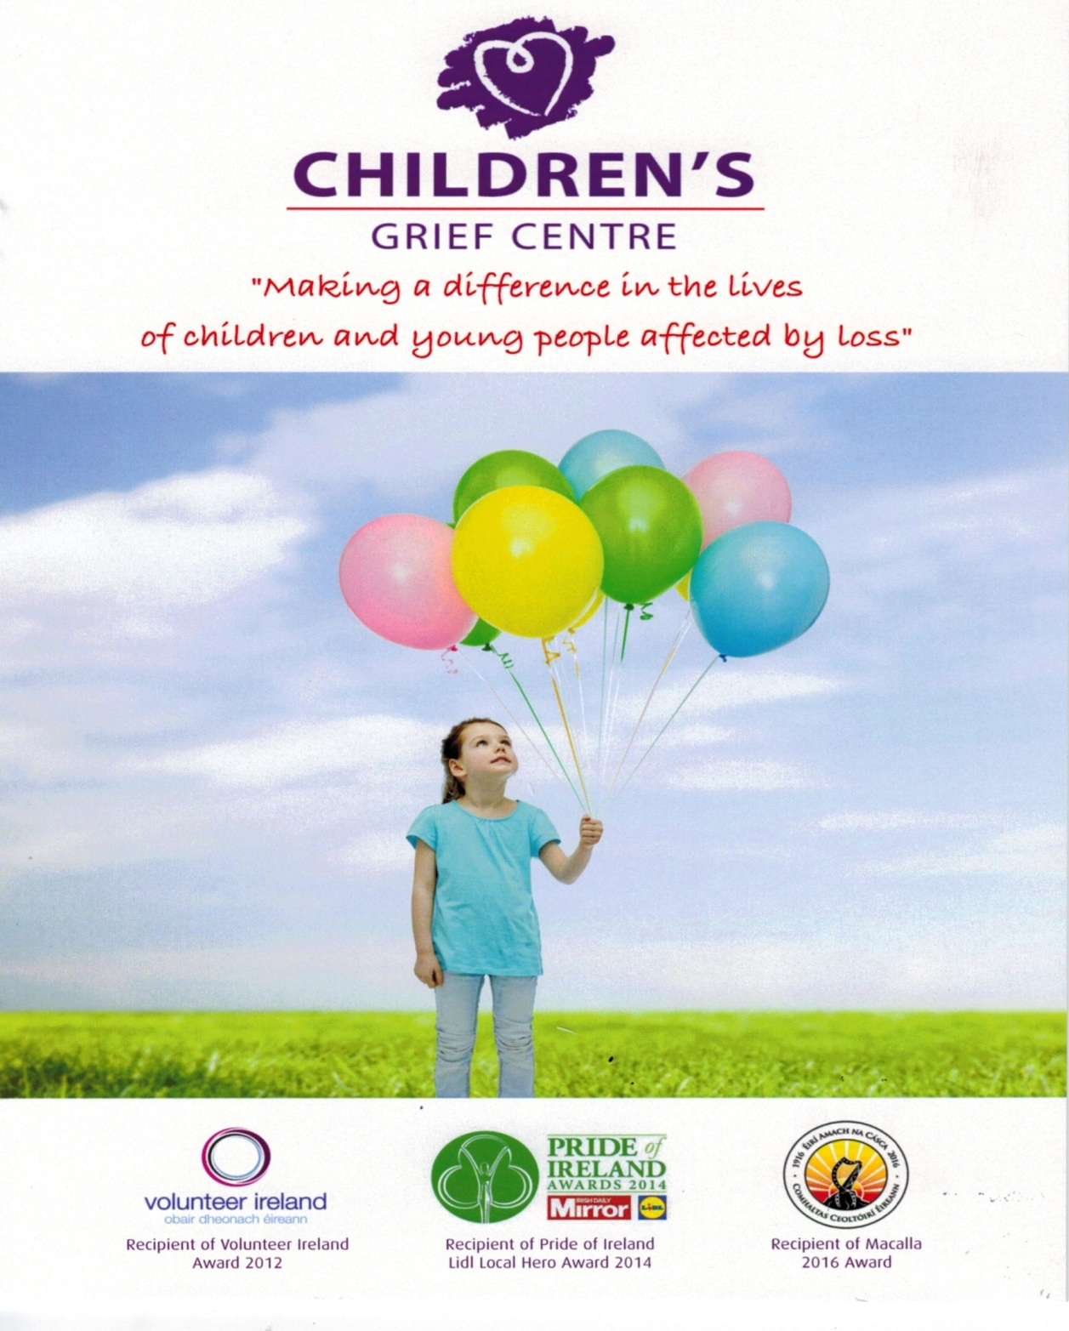

Children’s Grief Centre supporting children and young people affected by Loss through Death, Parental Separation and Divorce.
Charity Number: 20919

CONTENTS

Contents 2
Chair’s Report 3
Structure and Governance 4
Board members 5
Our Staff and Volunteers 6
Support Workers 7
Funding 8
Income and Expenditure 2016 9
Milford Care/Dr. Nixon/Children’s Bereavement Week/Winning Streak/Macalla 10
Number of Referrals 11
Reason for Referrals 12
Male / Female Referrals 13
Area Referred From 14
Support Worker Hours 15
Age Profile of Children referred 16
The Diocese of Limerick Synod/ Summer Party 17
Liaison with Schools, Organisations and Others 18
Workshops Delivered /Attended /media coverage/Challenges 19
Christmas Party/Evaluation process 20
Reflection 21
Company Information 22
Chair’s Report 2016
Throughout 2016, the Children’s Grief Centre continued to make a difference in the lives of children and young people affected by loss.
- Between them, the Director and volunteer Support Workers delivered 244 contact hours with parents and 1,194 contact hours with the 180 children and young people worked with during the year.

- 121 new referrals were received during the year, 63 boys and 58 girls, the majority of whom were between the ages of 8 and 13. Three quarters of all referrals were from Limerick city and county; two thirds were of children affected by the separation of their parents.

- The Director continued to liaise with a wide array of primary and secondary schools and community organisations. In addition, she delivered Workshops to 13 organisations, agencies, and community groups.

- A revitalised Fund-Raising Committee developed an attractive Information Pack which was sent out to over 100 businesses in the Munster area.

- The Centre continued to attract new volunteer Support Workers: these are Garda vetted and interviewed by the Centre Leader and Chair before commencing work.

- Two new members joined the Board of Management: Fiona Brosnan and Anne Comerford. The Board met on four occasions during the year. On a fifth occasion it was adjourned because a quorum was not present.

- The Board agreed at its July meeting to adopt the name Children’s Grief Centre, and this was subsequently approved by the Trustees.

- The Board continued to develop the Centre’s governance portfolio: a Volunteer Policy was drafted, discussed, amended and eventually adopted.

- A growing waiting list continues to be a concern. The success of the Centre raises the question: can we meet increasing demands for the service with the current, largely voluntary, workforce?

Phil Mortell
Chair

Structure and Governance
In September 2013, the Children’s Grief Centre was formally constituted as a registered charity with a legally binding Constitution.
  - Board Members
The Children’s Grief Centre reports to a voluntary Board, the members of which are appointed by the Trustees, the Sisters of Mercy, South Central Province. The Board members are drawn from diverse backgrounds and bring with them a wide range of skills and experience which contribute significantly to the work of the Centre.
The Board meets five times each year and has responsibility for overseeing all the business of the Centre. Board members, having served a three-year term at the time of the AGM, shall retire and may be eligible for re-election for one further three-year term.
The Board is working towards full compliance by the Centre with The Governance Code - a Code of Practice for Good Governance of Community, Voluntary and Charitable Organisations in Ireland.
Visit www.governancecode.ie for more information.
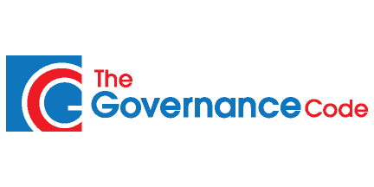

Board Members 2016
Name | Position | Joined Board
Philip Mortell | Chairman | September 2013
Majella Foley Friel | Board Member | September 2013
Blanaid McCurtain | Board Member | September 2013
Marie Stuart | Board Member | September 2013
Seamus Enright | Board Member | September 2013
Ita O’Brien | Board Member | September 2013
Seamus O’Brien | Board Member | September 2013
Therese Barry | Board Member | September 2013
Caroline Keane | Board Member | April 2015
Vicki Lynch | Board Member | November 2015
Anne Comerford | Board Member | June 2016
Fiona Brosnan | Board Member | June 2016
Majella O’ Connell | Board Member | September 2013  (retired February 2016)

  - Our Staff
Sr Helen Culhane Director Full time From Sep 2009
Sr Maura Flanagan Secretary Part Time From 2010
Ann Keane Secretary Part Time From Jan 2015
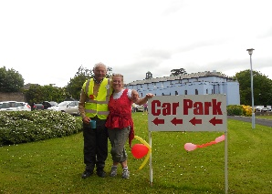
Geraldine Hannan Cleaner Part Time From Sep 2016

Our Volunteers

We are dependent on a wonderful network of volunteers for so many of our activities. They are the foundation of the Children’s Grief Centre. Without them, it would be impossible to serve as many families as we do.

We acknowledge with gratitude the work and commitment of all our volunteers, without whom we could not operate.
Volunteers make an immense and invaluable contribution to the operation of Children’s Grief Centre by:
- Supporting children/young people on a one to one basis
- Helping at our annual summer party
- Helping in our Administration Department
- Offering professional knowledge and serving on our Board of Management
Through their passion and commitment, volunteers create a safe, caring setting where grieving children can express all their emotions while finding their own path to healing from loss. Their compassion and kindness is very much appreciated by the Children’s Grief Centre and by the parents and children who attended in 2016.

Support Workers | OTHER
Janine Nehrig | ANNE ENGLISH: Administration
Mary Browne | SYLVIA LEE: Wages/Revenue
Theresa Kavanagh | FIONA BROSNAN: Data Entry / Fundraising Committee
Elaine Gleeson | DOLORES MADDEN – Maintenance
Claudine O’Dowd | UNA ORLANDI – Flowers
Dervilla Butler
Eta Butler
Jackie Slattery
Maura Hearty
Patricia English
Josephine Maloney
Christine Conway
Michele Flanagan
Pat Looby

  - Funding
The Centre relies heavily on the ongoing generosity of the Sisters of Mercy, who provide the Centre’s spacious and beautiful premises and meet bills for heating and light.
- In 2016 state funding accounted for €4,100. (Tusla)
- Community Foundation for Ireland €250.
- Donations amounted to €10,289.
- Fees/Donations for Workshop & Training €1,798.

  - Funding Raising Sub-Committee
Fiona Brosnan, Michelle Walsh, Philip Mortell and Betty Walsh
The Children’s Grief Centre would like to thank:
- Extreme Networks in Shannon for choosing us as the Charity they supported in 2016.
- Hi Life Tools, Shannon - the employees donated €1,000.00 to the Centre in December.
- The East Clare Musical Society are donating the proceeds of calendar sales to the Centre.
- Sr. Peggy Collins, RSM and Team, South Central Province, Naas, Co., Kildare

  - Being a volunteer with the Children’s Grief Centre
As a volunteer, stepping into the Grief centre is a warm, positive and welcoming experience. Helen, Anne and Maura make one feel very welcome. One’s experience, commitment and dedication to the task of helping young people with grief is cherished and valued. Helen always provides a listening ear and genuine interest in how the volunteer is progressing within the Centre. There is always nice tea, coffee and biscuits for volunteers.
The Centre supports volunteers with supervision, case management and an empathic response. There is professional group supervision held regularly with an experienced practitioner, and this is held in a supportive and welcoming manner. All the volunteers that work in the Centre are focused professionally on the ethos of providing empathic outcomes for the young people that come to the Centre. The Centre is a calm, relaxing and therapeutic space for young people and their families. This welcoming space is very evident to me as a volunteer and I really enjoy giving some of my time to the Centre.
Michelle, Support Worker

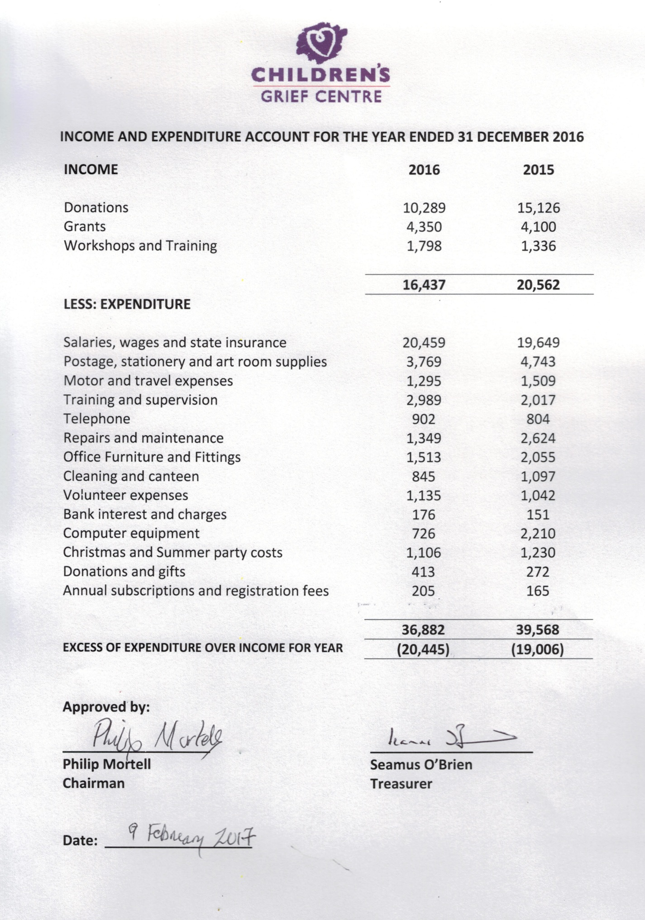

Milford Care Compassionate Communities We were awarded with a grant (€800.00) by Milford Care Compassionate Communities to fund a resource library in the waiting room for parents/guardians. Books on separation, divorce and bereavement are available for parents to read.

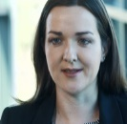
Dr. Liz Nixon We are indebted to Dr. Nixon, Trinity College Dublin, for completing a piece of research on our evaluations sheets with both parents and children. The majority of respondents identified how the service provided “a place to talk” for their child; so, that “the children could talk to someone outside the family about the situation”. The value of listening to children stands out, this is what the children said mattered most.

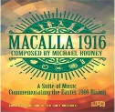
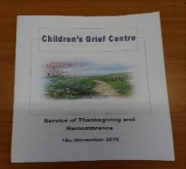
Winning Streak RTE In January RTE came on site to film a segment for the Winning Streak Saturday show on RTE 1. As part of the filming they interviewed Phil Mortell, Seamus O’Brien, Anne Comerford (Parent member of BOM) and Helen Culhane (Director). The short film can be viewed on our website and Facebook page.

MACALLA 1916 As part of the State’s commemoration of the 1916 Rising, The Comhaltas National Folk Orchestra of Ireland undertook a week-long tour of major venues in Ireland. As part of the commemoration, Comhaltas identified seven people who received a special coin and copy of the 1916 proclamation on the 3Oth, March at the Lime Theatre, Limerick. Our Director, on behalf of the Children’s Grief Centre, was one of the seven to receive the award. The seven people were selected as people who have fulfilled and continue to fulfil the idealism and the vision as noted by the seven signatories of the 1916 Proclamation.

Children Bereavement Week To mark Children bereavement week in November 2016, we held a Ceremony of Remembrance. Children, young people and their parents attended the service. We had lovely refreshments. The children and parents/guardians were given the candles to take away and they can light them again in memory of those who have died.

Number of Referrals 2016

121 new referrals were received in 2016.
We saw 180 children and young people during 2016.

Reason for Referral 2016

Reason for Referral | Jan | Feb | Mar | Apr | May | June | July | Aug | Sept | Oct | Nov | Dec | YTD
Separation | 5 | 3 | 8 | 10 | 14 | 11 | 5 |  | 9 | 6 | 4 | 5 | 80
Bereavement | 3 | 7 | 2 | 4 | 6 | 4 | 3 |  | 6 | 4 | 2 |  | 41
Totals | 8 | 10 | 10 | 14 | 20 | 15 | 8 | 0 | 15 | 10 | 6 | 5 | 121

Male / Female Referrals 2016

Area Referred From 2016

Limerick - 94

Clare - 14
Tipperary - 10

Other - 4

Support Worker Hours 2016
(Note: Hours are calculated on the basis of allocating 2 hours per session, to include preparation beforehand, and writing up notes afterwards)

Total Hours Parents: 244

Total Hours Children: 1194

Age Profile of New Referrals 2016
(121 new children and young people were referred)

The Diocese of Limerick Synod

The Synod was the first of its kind in Ireland in fifty years, and the first in Limerick in over eighty years. The eighteen-month process saw input from over 4,000 members of Limerick Diocese. We are delighted that our proposal to the Synod was supported and we look forward to working with the Diocese of Limerick.
Bishop Brendan Leahy wrote,
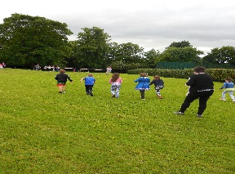
“Firstly, there are those proposals brought forward by groups or agencies who are already working in areas and who have experience and expertise, for example Compassionate Communities, Bedford Row, Children’s Grief Centre. Here the strategy is to work with and support these groups rather than working in parallel”.

Summer Party

The annual Summer party was held on Saturday June 25th, for the children who had availed of the service. 47 children and 27 parents attended. Numerous volunteers were on hand to help with the party. The children engaged in a number of activities varying from nail painting, face painting to creative games and art work. The day ended with a barbeque. Feedback from parents and children was overwhelmingly positive.

One parent gave the following feedback in their evaluation of the Summer Party:

“As always, it was a very good day for the children and their families.
The art sessions worked extremely well.
The races and other activities worked very well too.
The BBQ at an earlier time was excellent
Our girls loved everything about the party
. Well done as always, on an excellent day. Speaking as a parent,
I really appreciate that this event takes place”.

  - Liaison with Schools, Organisations and Others
The Children’s Grief Centre plays a key role in providing advice and information to parents, teachers and a wide variety of Agencies.
The Director liaised with a number of primary and secondary schools during the year. She also provided training and information to help organisations and individuals deal with grief issues.
ORGANISATIONS
Adapt House, Limerick
Anam Cara
Augustinian Pastoral Office
Barnardos
Bluebox
Ballynanty Health Centre
Community Companions Moyross
CAMHS Limerick
CAMHS Newcastlewest
CAMHS Nenagh
Charities Regulatory Authority
Clarecare
Embrace Farm
General Practitioners Association
Irish Hospice Foundation
Limerick Mental Health Services
Limerick Social Services
Limerick Volunteer Centre
Limerick Social Service Parent Support Programme
Milford Care Centre
Mary Immaculate College
Pieta House
RTE
Rainbows Ireland
St Gabriels
Tralee Bereavement Group
Trinity College Dublin
TUS Limerick

PRIMARY SCHOOLS
Our Lady Queen of Peace | Limerick
Killaloe Primary School | Clare
Salesian Primary School | Limerick
Coolock Mercy | Dublin
Caherline National School | Limerick
St Mary’s | Limerick
Kilfinane | Limerick
Broadford | Limerick
Ballingarry | Limerick
Catherine McAuley School | Limerick

SECONDARY SCHOOLS
Laurel Hill | Limerick
Salesian Secondary School | Limerick
Ard Schoil Mhuire | Limerick
St Augustine’s | Limerick
Presentation Secondary School | Limerick
Gael Cholaiste | Limerick

  - Workshops – Conferences attended
- Attachment in Adult Life – Tralee
- Art Therapy Conference – Cork
- First Light Conference – Portlaoise
- Social Connection Conference – LIT
- Expressive Play, Child Trauma & Neglect Conference – Tralee
- National Conference of Children’s Bereavement Network – Dublin
  - Media Coverage
- In February, the Director was interviewed by Derry O’Malley for Limerick Community Radio.
- In January RTE came on site to film a segment for the Winning Streak programme.
Challenges
The greatest challenge facing the Children’s Grief Centre is the ever-increasing number of children on our waiting list and on-going funding. At the end of December, we had 113 children on the waiting list and this remains the greatest ongoing challenge as we face into 2017.

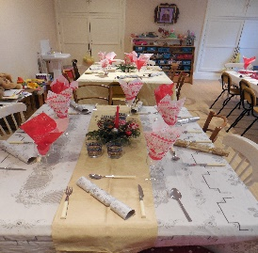
Christmas Party
Our Christmas party was held on the 9th December 2016 for volunteers and the board of management. A very enjoyable night was had by all!

Evaluation Process
It is our practice during the last session to ask parents and children to complete an evaluation sheet. The purpose is to get feedback from both parents and children on their experience of the service and how the service can be improved.

Feedback from Children
- Being able to talk to people and feeling that there is someone able to support me.
- Just knowing why they broke up.
- I could say what I wanted without being afraid of making the people that I love upset.
- Yes. Changed my life. I don’t feel crazy anymore.

  - Feedback from Parents
- An over-riding atmosphere of feeling comfortable and welcome. Incredible sense of safety and wellbeing which my son adapted to very quickly and trusted in the process.

- I found that my son came out of himself and is able to speak to me more if he has a problem and he knows now it’s not his fault.

- We lost Tom’s mom when he was four and while I always tried to be open and honest with Tom and to engage in a conversation whenever he spoke of his mother. I was worried that as he got older that he had not actually grieved. The opportunity for Tom to talk and explore his grief and feelings with an outside person has really helped him.

.

When we honestly ask ourselves which person in our lives means the most to us, we often find that it is those who, instead of giving advice, solutions, or cures, have chosen rather to share our pain and touch our wounds with a warm and tender hand. The friend who can be silent with us in a moment of despair or confusion, who can stay with us in an hour of grief and bereavement, who can tolerate not knowing, not curing, not healing and face with us the reality of our powerlessness, that is a friend who cares.
Henri Nouwen

WE ARE here to

  - BANKING DETAILS
  - Bank: Bank of Ireland, 125 O’Connell St, Limerick
  - Account Name: Children’s Grief Project
  - Account No: 28979708
  - Sort Code: 90-43-17
  - IBAN: IE40BOFI90431728979708
  - BIC: BOFIIE2D

  - INFORMATION
Westbourne, Ashbourne Avenue, South Circular Road, Limerick
(061) 224627 (087) 9851733
info@childrensgriefCentre.ie www.childrensgriefcentre.ie

“Making a difference in the lives of children
and young people affected by Loss”

