Support Books for Parents of Bereaved Children and Teens

We’ve compiled the below list of books on childhood bereavement which may be helpful. Most can be bought online from your local book shop, Amazon.co.uk or Book Depositry. It may also be possible to borrow them from your local public library or an academic institute.

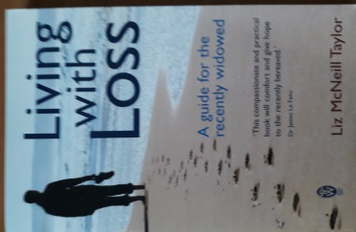
Living with Loss by Liz McNeill Taylor: A guide for the recently widowed

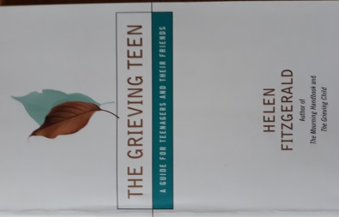
The Grieving Teen by Helen Fitzgerald: A Guide for Teenagers and Their Families

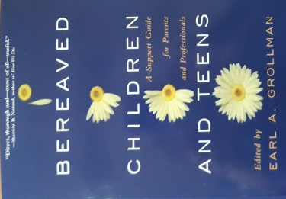
BEREAVED CHILDREN AND TEENS by Earl A. Grollman: A Support Guide for Parents and Professionals

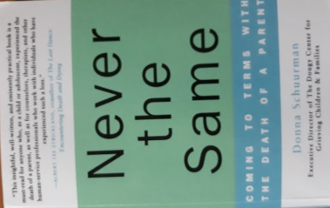
Never the Same by Donna Schuurman: A practical book for anyone who, as a child or adolescent, experienced the death of a parent, as well as for counsellors and therapists.

