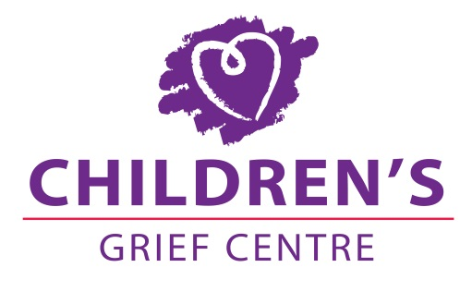

Child Safeguarding Statement

Children's Grief Centre provides support to school aged children and young people affected by loss through death, separation and divorce.

The purpose of this policy is to safeguard children, young people and their families on our premises.

Children's Grief Centre Safeguarding Statement is a guidance document for staff to identify and respond to any allegations or suspicions of child abuse or neglect. The document adheres to the Department of Children and Youth Affairs National Guidance for the protection of and welfare of children, published in 2011, and the Children's First Act 2015. This Safeguarding Statement is displayed on the Children's Grief Centre website and in the Children's Grief Centre.

Children's Grief Centre adheres to the Children's First Act 2015, and Article 1 of the UN Convention on the Rights of the Child. The definition of a child is a person below the age of 18, who is not or has not been married. The safeguarding policy applies to all staff members of Children's Grief Centre including volunteers and board members.

The following principles underpin the Child Safeguarding Statement:

1. The Welfare of the child is of paramount importance
2. Children's Grief Centre is committed to respecting the right to dignity and bodily integrity of every child and to protect those rights under the UN Convention on the Rights of the Child as outlined in the Articles 2,3 and 6
3. All Children's Grief Centre staff have the responsibility to protect Children and have a duty of care to report child abuse as set out in The Children First Act 2015 and in accordance with The National Guidelines for the protection of children 2011
4. Children's Grief Centre endorses The Children First Act 2015 and is committed to developing policies and procedures in line with legislation
5. Children's Grief Centre will not knowingly engage any person or organisation, or fund any project that poses a risk to children
6. Children's Grief Centre will ensure that all staff receive appropriate training in Child Protection
7. Children's Grief Centre will ensure that its recruitment policy adheres to best practice and that all staff are Garda vetted by the Garda Vetting unit

